# ALO CAR RENTAL

**Project Team Members:**

1. **Venganti Raju (Team Leader)**
2. **Bala Vignesh**
3. **Hari Vignesh**
4. **Yadalapalli Greeshmitha**

# 1.0 DOCUMENT PURPOSE

The Main objective of the ALO Car Rental is to manage the details of Customer, Cabs availability and details of the cabs. This project will help the customer to check whether the cab is availability or not and to know how much have to be once the car is rented.

The project is built totally built at administrative end and staff end and it is user friendly where the admin and end users can use it.

The purpose of the project is to build application program to reduce the manual work for managing the Details of Car Availability. It tracks about all the details of customer and customer booking.

This project includes modules such as

1. Login
2. Car Registration
3. Customer Registration
4. Rental Car
5. Return Car

# 2.0 Module Use case

**2.1 Login**

In Login module, the Login page is to access the website.

* Username
* Password

**2.2 Car Registration**

This module contains a credentials of about the car make and model which is available or not.

* Car Id
* Car Number.
* Make
* Model
* Available

**2.3 Customer Registration**

This module contains a new customer registration form, where they fill the form which has fields like ,

* Customer Id
* Customer Name
* Customer Address
* Customer Contact Number

**2.4 Rental**

Here all the requirements according to the customer and car availability and how much have to be paid and total number of days u want to rent it from start date and end date.

* Car Id
* Customer Id
* Fees
* Start Date
* End Date

**2.5 Return**

This module is to identify the customers they have to pay a penalty for the car they rented if the days has been elapsed.

* Car Id
* Car Number
* Customer Id
* Return Date
* Elapsed Days
* Fine

# 3.0 Design and Implementation Constraints

**3.1 Database:** The system shall use the MS SQL Server Database, which is open source and free.

**3.2 Operating System:** The Development environment shall be Windows10

**3.3 Web-Based:** The system shall be a Web-based application ASP.Net

**4.0 Define module & Functionality:**

The system functions can be described as follows:

* **Registration:** When the customer enters the page, they have to register and then new users are added to the database.
* **Login:** When name and password is matched it allows the user to dashboard or else it denies the user to enter into website.
* **Booking:** here customers enters all the required details of the customer and confirm the booking.

**5.0 System Analysis**

System analysis is the first and foremost step performed in developing the software to solve a particular problem. In the analysis part, a software developer examines the requirements. Carrying out preliminary investigation identifies these requirements

* Analysis consists of two sub phases:

1. Planning
2. Requirement definition

During planning phase, cost estimates and work schedules will be planned. Requirement definition is a specification that describes the processing environment, the required software functions, performance constraints (Size, Speed, Machine Configuration) and exception handling.

**6.0 SQL Tables:**

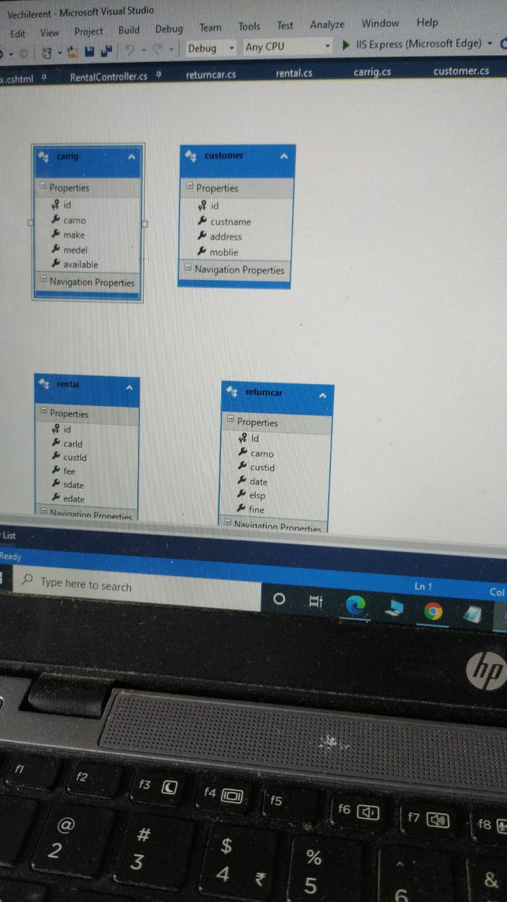

**7.0 Use Case Diagram**

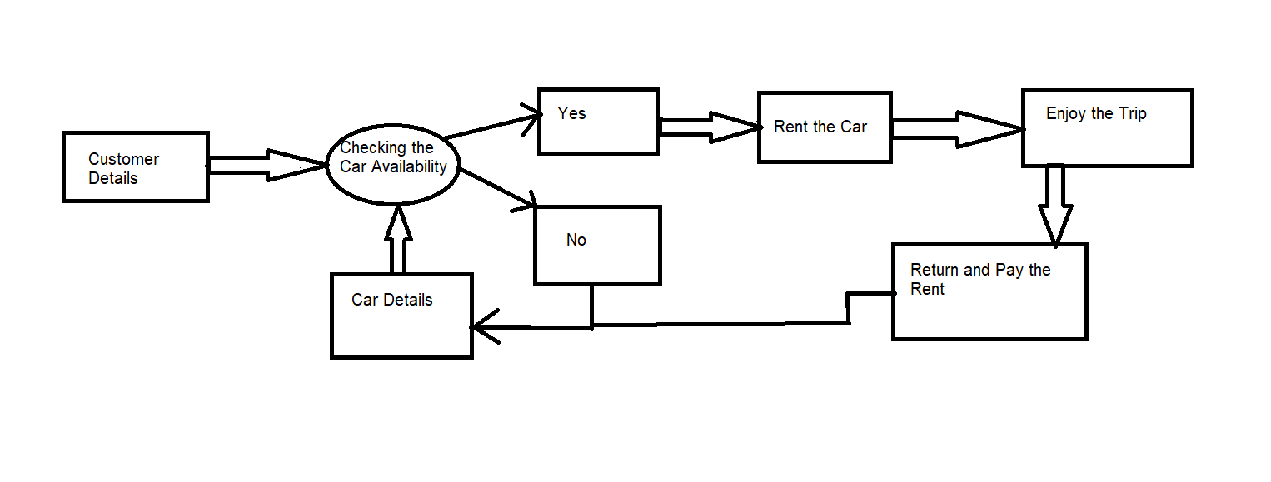

**8.0 Technical:**

* HTML 5( HyperText Markup Language)
* CSS (Cascade Style Sheet)
* BOOTSTRAP v4
* JQUERY
* SQL ( Structured Query Language)
* MVC ( Model View Controller )
* Validation
* Session

**10.0 Conclusion**

Car Rental System provides a required platform for managing the Details of Customer and Booking the car according to the customer needs. This platform is connecting company with customers and help to plan their special occasion.